Who am I POURING into
As you look at this picture, think about you and all the people you serve. Think of you being the bottle in this picture that pours into everyone else. I think it is very easy to see how this graphic representation directly resembles your life. Lots of people rely on you every day, and you only have so much time and energy to support them all. Words like burnout, exhaustion, anxiety, frustration, depression, and the list goes on and on because you can’t do it all. You keep telling yourself tomorrow will be better, or next week the load will be lighter, but the reality is that you continue to fight this battle, losing yourself in the process. Let’s see how we can unpack this to develop a better, healthier, and more sustainable approach to serving others.

Representation of Today –
This image represents you as the bottle pouring your contents, things like knowledge, wisdom, skillset, love, support, etc., along with your time and money into those you commit to serving. As you can see, the contents of this bottle versus the amount the glasses can hold, there just isn’t enough to keep them all filled. I think this picture is such a great representation of the majority of people’s lives today – trying to do way too much and losing themselves in the process.

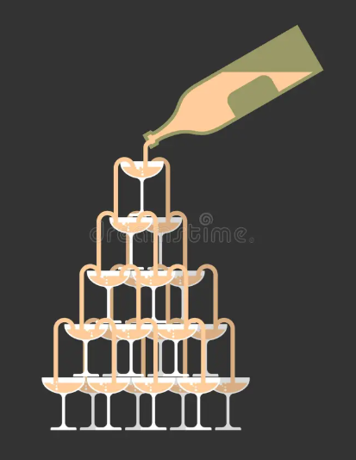

“There’s only one thing more precious than our time and that’s who we spend it on” - Leo Christopher

A Different Perspective – Using the same image above
Let’s take the same image we just looked at, you know that one where you’re serving everyone else and losing yourself in the process, but this time we are going to focus and concentrate on the bottle and the very first glass of the pyramid.

The Glass –
This first glass now represents yourself. Before anyone else underneath you on the pyramid of life can get anything, your cup must first be filled to then overflow. In life, people don't know how to take care of themselves properly first, and that is one of the biggest reasons they don’t feel well. When your focus is all about everyone else, you never have time or want to make time to take care of yourself – this is a recipe for disaster. In this worksheet, you are going to start learning to focus on filling your glass first before anyone else’s.

The Bottle –
You are going to learn what contents are typically in your bottle now, so you can understand whether this is healthy stuff that you are pouring into yourself and others, or if you are drinking poison that then flows into everyone else under you. You want to make sure that whatever you are consuming is truthful, helpful, and promotes overall well-being. You must be mindful of what you consume, or it will slowly take you down!

By shifting your perspective, you can see that you have a lot more control over how much the bottle pours out, along with the contents of it, and what happens with the first glass of the pyramid. Starting to focus on yourself and what you consume will provide the recipe for a healthier life. It will also teach you when you need to say NO to things that don’t serve you.

Current Contents of your Bottle –
What are you currently putting into your bottle, or what has society or the world put in there for you to consume. Think of this as the ingredients that make up the contents of your bottle currently:
Negative Items: | Positive Items: | Neutral Items – Things you’re not sure of: | How do you feel about what you consume daily?

“There’s only one thing more precious than our time, and that’s who we spend it on” - Leo Christopher
New Contents of your Bottle –
Now that you have a better understanding and more control over the contents of your bottle, what will it take to build a new recipe? Think about what ingredients will help you live with more sustained joy throughout all moments of life.
What are the ingredients, and how do I build this new, healthier recipe?

The Glass –
How does it feel not to have a glass for myself in the pyramid of life right now?

Why is it so important currently for me to serve everyone else first, and to just keep pouring myself into others, even when I am tired, exhausted, lost – WHY?

“There’s only one thing more precious than our time, and that’s who we spend it on” - Leo Christopher
For me to feel like I belong as the first glass at the top of life’s pyramid, what has to change?

What have I learned after completing this worksheet:

What do I want to work on changing and WHY:

My AHA moment(s):

“There’s only one thing more precious than our time, and that’s who we spend it on” - Leo Christopher

