My Wheel of Life
This self-development tool, called the Wheel of Life, was created in the 1960s by Paul Meyer. It was designed to help people see, in real time, what was important to them and the level(s) of attention they were devoting to sustaining and growing each of these areas. Completing this Wheel of Life exercise is not meant to add stress or anxiety to your life; it is meant to give you feedback as to where your life is currently, allowing you to adjust as you see fit.

Let’s help you design your own Wheel of Life:
The wheel can be designed with as many or as few pie pieces as you wish; there are no rules. The wheel in this example uses eight different pie pieces focusing on business/career, finances, health, family & friends, romance, personal growth, fun and recreation, and physical environment. The best way for you to determine how many pie pieces you want to reflect on within your wheel is to make a list of all the things that are important to you right now at this moment in your life.

Once you have the pie pieces determined and drawn, add your labels around the outside of each piece. Next, in the example below, you will see a scale on each pie slice, starting at zero at the center and 10 near the outer edge of the circle. This is where you would use this scale to grade each of your pie pieces. Grading is based on your energy, your effort, your dedication, and the level of care you put into this area of your life. Here are a few examples of how the scoring works for each of your pie pieces:
- If you put forth zero effort and it is just not a priority at the moment, then this area of your life gets a score of zero, which is located at the center of the circle.
- If you put forth constant, consistent effort to maintain and grow this area of your life, and it is something that is very important to you, then this area gets a score of 10, which is located on the outer diameter of the circle.
- Whatever score you choose for each of your pie pieces, start at the center and shade in the area all the way up to where you scored yourself. This will provide a visual as to how you are doing in each of the areas you have listed on your Wheel of Life.

“A beautiful thing happens when you start to pay attention. As you participate more in your own life, you will breathe more life into your soul” – Unknown
Sample Wheel of Life Design

- In the sample Wheel of Life shown below, you can see the pie pieces along with all the things that are important right now in life, and the scale from zero to ten used for grading.
- This wheel does not show the shading; see the Completed Wheel of Life below for that example.

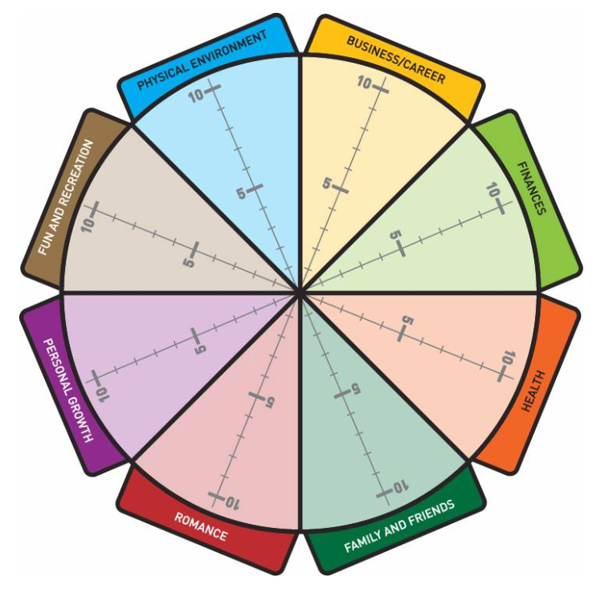

“A beautiful thing happens when you start to pay attention. As you participate more in your own life, you will breathe more life into your soul” – Unknown
Completed Wheel of Life

- This is an actual wheel of life that someone did. You can see the shaded areas representing their individual scores. In this example, they had 12 pie pieces, and you can see the reality of trying to maintain 12 areas of life. It is extremely difficult, and their lives are a bit all over the place.

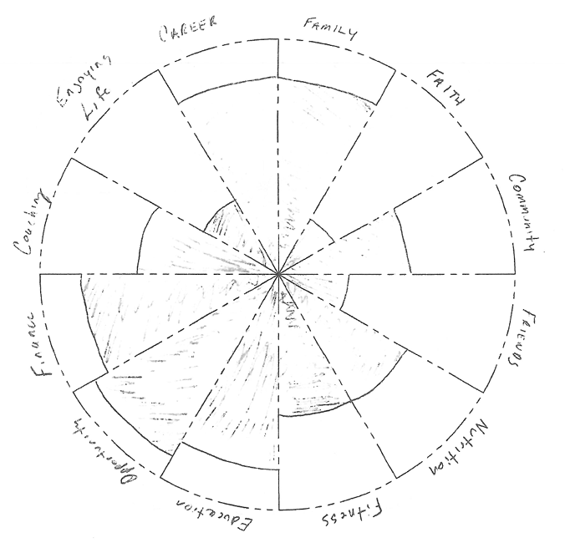

“A beautiful thing happens when you start to pay attention. As you participate more in your own life, you will breathe more life into your soul” – Unknown
Reflecting on my Wheel of Life

Once you have completed your Wheel of Life and have had some time to reflect on the message(s) you are getting from it, go ahead and process the following questions. Please remember the goal here is not to “balance” everything, because that really doesn’t exist in life. The goal for you is to identify areas on your Wheel of Life that you wish to improve, 1% at a time. That’s right, 1% at a time, because making slow and steady progress is what will ensure that your progress is sustainable, and that is what you are after.

What is the first thing that jumps out at you about your Wheel of Life?

What are the areas within your Wheel of Life that are going well right now?

What are the areas within your Wheel of Life that are NOT going well right now?

When you look at your Wheel of Life, what emotion(s) are you feeling & why?

“A beautiful thing happens when you start to pay attention. As you participate more in your own life, you will breathe more life into your soul” – Unknown
How did my Wheel of Life get like this?

For things to change in my Life, what must be TRUE?

What have I learned from my Wheel of Life:

What do I want to work on changing, and why??

My AHA moment(s):

“A beautiful thing happens when you start to pay attention. As you participate more in your own life, you will breathe more life into your soul” – Unknown

