My Leaves - I REAP what I Sow
This is a very fun artistic spin on viewing yourself from the perspective of a tree. Feel free to use this as a template for you to build your own model of the tree you represent. This will give you more space to create your own leaves in whatever shapes and colors you wish, and to add very specific labels to them to match your journey and story. You can also be very specific in labeling the roots, detailing all the hard work you have done and continue to do in support of your growth. People don’t see all your blood, sweat, and tears; instead, they make up stories based on what they see and what they know. You know what is true and what is real; be proud of yourself because that is what truly matters most. Have fun with this little art project, and don’t be afraid to share it with those in your life who have earned the right to see it. I hope it shows you more of how resilient and amazing you really are.

What people see;
Their perception of you

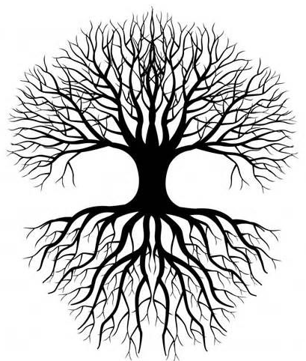
What people don’t see,
The hard work, the grind, the blood,
The sweat, the tears, the sacrifice

“Trees are our closest relatives. What trees exhale, we inhale; what we exhale, they inhale. They are half our respiratory system.” – Jaggi Vasudev
Your Roots:
- Your root systems are things that need to be nurtured and developed every single day. You must create a healthy environment if you expect to produce the outcomes (your leaves) you desire and that you are capable of producing. As you build more roots that continually get stronger as you do the work, think about your influences, your values, your beliefs, your pain, the way you think, your perspective(s), your decisions, etc. Your roots are what make you stable and strong – this is the foundation of your life. It is important to remember that while part of your root systems can be very complicated and at times out of your control, focusing on what you can control will help you become more of a creator in your life instead of feeling as though you are a victim of it. The winds are going to come; it's time to get busy building a root system that can withstand anything that comes your way!
Your Trunk:
- You are the core of it all, and how you see yourself is by far the most important thing in your world. Without you and your constant dedication to your overall wellness, nothing else matters. This is where your focus on your mental, physical, spiritual, emotional, and financial wellness is so critical to your overall strength and resilience. Without a strong trunk, you have no place for branches you grow, and with no branches comes no leaves!

Your Branches:
- Your branches are your support systems as they bridge the gap between what work you do that no one sees and the beautiful leaves that the world gets to enjoy. Without these branches, displaying your beauty would not even be possible. This is where you want to look at your support systems and who is responsible for your successes. No one gets anywhere in life without the help and guidance of others, so if you haven’t taken the time to reflect and appreciate this part of your life, now is a great time to start. One last thing, consider letting your branches know just how important they are to you; they would greatly appreciate your kindness.

Your Leaves:
- Each leaf of your tree is unique and special in its own way. The work that you put into your roots and your branches will determine the size, shape, color, heath and quantity of your leaves. People will see these leaves in the form of your skills, your passions, your love, your kindness, your weaknesses, your effort, etc. These are your leaves representing who you are and what you stand for in life. What do you have to offer the world, and what do you want them to see? You’re doing the hard work, so let the world see who you were meant to be!

“Trees are our closest relatives. What trees exhale, we inhale; what we exhale, they inhale. They are half our respiratory system.” – Jaggi Vasudev
My ROOTS, where are they STRONG: | My ROOTS, where are they WEAK:

My TRUNK, where am I STRONG: | My TRUNK, where am I WEAK:

My BRANCHES, where are they STRONG: | My BRANCHES, where are they WEAK:

My LEAVES, what am I most PROUD of: | My LEAVES, what am I hiding from the world & why:

What have I learned about myself after completing this worksheet?

My AHA moment(s):

“Trees are our closest relatives. What trees exhale, we inhale; what we exhale, they inhale. They are half our respiratory system.” – Jaggi Vasudev

