How I COMPLICATE My Life
In 2008, Dr. David D. Burns, M.D., published a self-help book titled “Feeling Good Together,” which focuses on using CBT (Cognitive Behavioral Therapy) techniques to improve relationships. In this book, one of the things that he focused on was “The secret to making troubled relationships work.” Here, Dr. Burns teaches us how ten distortions can trigger conflict, and this worksheet is going to allow you to see how these distortions can or currently are complicating your life.

Here are the ten distortions that can complicate your life – by Dr. David D. Burns, M.D.
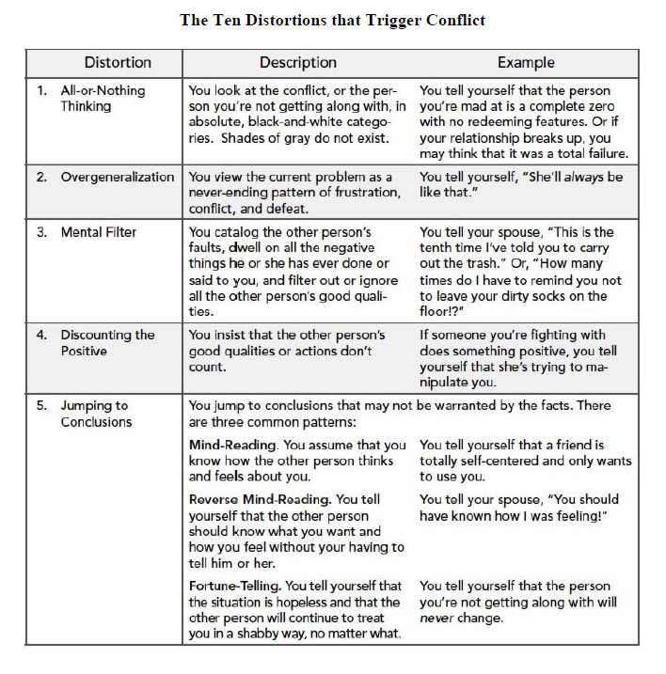
“Strange how complicated we can make things just to avoid showing what we feel!” – Erich Maria Remarque
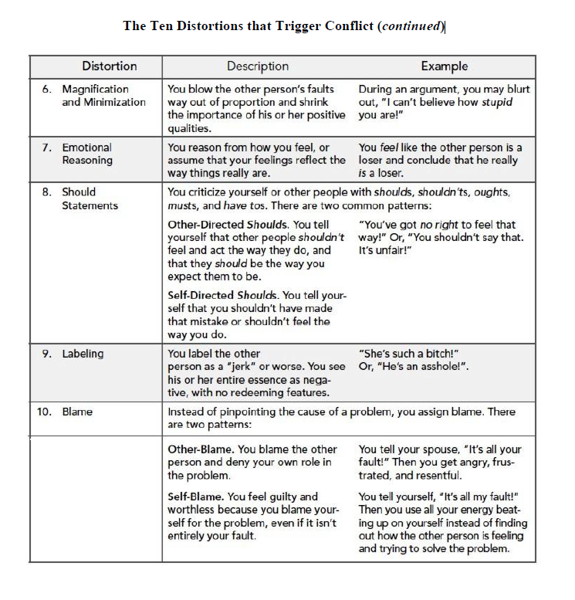

“Strange how complicated we can make things just to avoid showing what we feel!” – Erich Maria Remarque
Let’s look at each of these tools to see how you use each of them and whether they are helpful to you or if these tools are making your life more complicated.

The Distortion | When do I use this tool? | Does using this tool help me? How? | Does using this tool complicate life? How?
All or Nothing Thinking
Overgeneralization

Mental Filtering
Discounting the Positives
Jumping to Conclusions

“Strange how complicated we can make things just to avoid showing what we feel!” – Erich Maria Remarque
The Distortion | When do I use this tool? | Does using this tool help me? How? | Does using this tool complicate life? How?
Magnification and Minimization
Emotional Reasoning

Should Statements
Labeling
Blame

“Strange how complicated we can make things just to avoid showing what we feel!” – Erich Maria Remarque
How am I making my life more complicated than it has to be?

What are my go-to Distortions – WHY do I use these so much?

What has this worksheet taught me?

What do I want to start working on changing, & why?

My AHA moment(s):

“Strange how complicated we can make things just to avoid showing what we feel!” – Erich Maria Remarque

