My Mindset
Carol Dweck wrote a book called “Mindset,” which explores how different mindsets can help us better understand motivation and perspective. One of the central concepts from this book is that “the view you adopt for yourself profoundly affects the way you lead your life.” In her book, she talks about the differences between a growth mindset and a fixed mindset. This worksheet will focus on both mindsets to help you understand what your go-to mindset is and how different life situations can change your usual mindset.

Here’s a good visual of both mindsets and the standard approaches each takes in life. It is easy to see that the growth mindset is one that lives for challenges, loves feedback, and has an overall positive outlook on life. The fixed mindset is more rigid, absolutely dislikes change, and can have a more negative outlook on life.

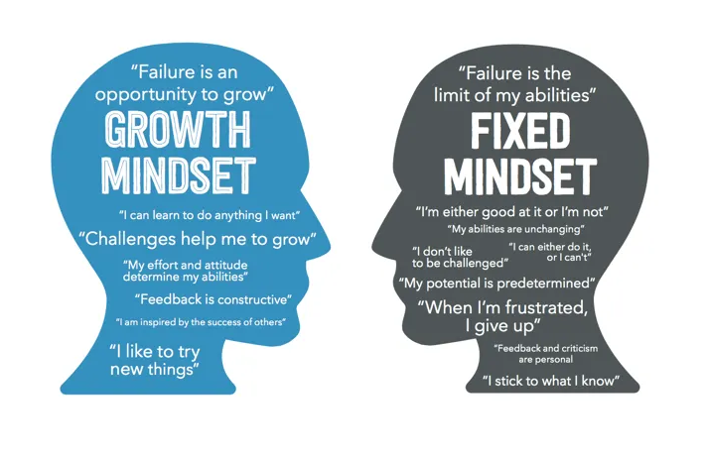

“Once you master your own mind, anything is possible” - Unknown
Let’s look at your typical or go-to mindset, and let’s try to understand it a little more.
What is my typical or go-to mindset? | How is this mindset helpful? | How is this mindset holding me back? | Anything I want to change? Why or Why Not?

Now let’s look at your emotions, decision-making process, and ability to connect with others based on your typical or go-to mindset.
What is my typical or go-to mindset? | What are the typical emotions I feel? | How well am I able to make decisions? | How is my ability to connect with others impacted?

“Once you master your own mind, anything is possible” - Unknown
When your mindset shifts from one to the other, why does it do this? What are the situations in life that cause these mindset shifts, and what are they trying to teach you or protect you from? The grid below will help you examine three situations in which your mindset changes.
What is the situation that causes my mindset to shift? | My mindset shifted from _____ to _____: | Why did my mindset shift? | What is this shift in my mindset teaching me or protecting me from?
Situation #1

Situation #2

Situation #3

Now let’s look at your emotions, decision-making process, and ability to connect with others in light of these shifts in mindset. The grid below works with the one above, giving you some additional questions about situations that change your mindset.
What is my shifted mindset? | What are the emotions I feel? | How well can I make decisions? | How is my ability to connect with others impacted?
Situation #1

Situation #2

Situation #3

“Once you master your own mind, anything is possible” - Unknown
How is my typical or go-to mindset adding value to my life and my relationships?

In what ways do my different mindsets harm me or my relationships with others?

What has this worksheet taught me?

What do I want to start working on changing & why?

My AHA moment(s):

“Once you master your own mind, anything is possible” - Unknown

