My Ikigai – A Reason for Being
This Japanese concept uses four circles, commonly known as a Venn diagram, to help you discover aspects of your life that may be completely hidden or just a bit hard to understand.
- Circle one is focused on exploring more about what you love.
- Circle two is focused on what you are good at in life.
- Circle three is focused on what you can be paid for in the service of others.
- Circle four is focused on what the world needs that you can supply
By focusing on these four circles, you will be able to learn a lot more about yourself and your current state of being. This process will not solve all your confusion, but it will clarify some things, helping you see more of what is true for you.

Below is an overview of the Ikigai Diagram, and you can see how it works.

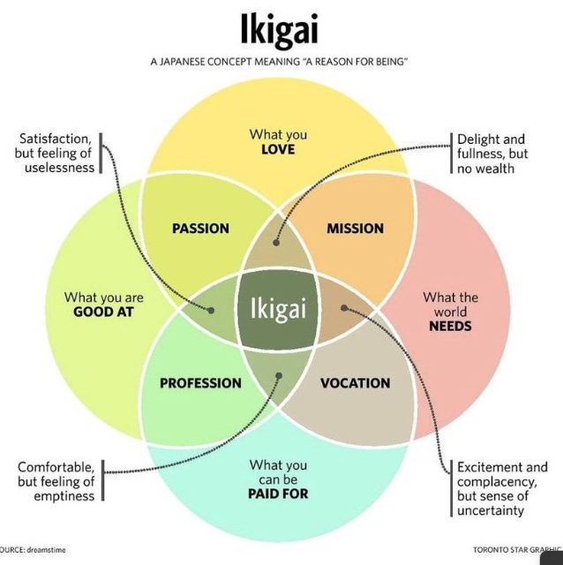

“Your real self may be hiding somewhere. Look for it within, and when you find yourself, you can freely be what you want to be” – Michael Bassey
Circle #1 – What do I love – (all aspects of life)
- Think about all the things all the way back into your childhood.
- Think about all the things that make you extremely happy.
- Think about the things that you do where you lose all track of time
- Think about the things that you do, where you can’t wait for the next opportunity to do it again.
- Even if you’re not sure, go ahead and jot your thoughts down in this circle, as this is an exercise to allow you to explore. This is not about being perfect, it’s about being real.



“Your real self may be hiding somewhere. Look for it within, and when you find yourself, you can freely be what you want to be” – Michael Bassey
Circle #2 – What am I good at – (all aspects of life)
- Think about your natural talents and skills.
  - These are the things that bring joy in the service of others.
- What do other people often ask you to help with?
- What aspects of life are you confident in?
- Even if you’re not sure, go ahead and jot your thoughts down in this circle, as this is an exercise to allow you to explore. This is not about being perfect, it’s about being real.
- It is ok to repeat some of the same things you listed in other circles.

“Your real self may be hiding somewhere. Look for it within, and when you find yourself, you can freely be what you want to be” – Michael Bassey
Circle #3 – What can I be paid for in service of others – (all aspects of life)
- Think about your marketable skills and the services that you possess.
- Think about the things that make you unique.
  - Those things that someone would come to you before anyone else.
- Even if you’re not sure, go ahead and jot your thoughts down in this circle as this is an exercise to allow you to explore. This is not about being perfect, it’s about being real.
- It is ok to repeat some of the same things you listed in other circles.

“Your real self may be hiding somewhere. Look for it within, and when you find yourself, you can freely be what you want to be” – Michael Bassey
Circle #4 – What the world needs that I can supply – (all aspects of life)
- Think about what problems you see in the world right now that people need help solving, where you can provide those solutions.
  - There are a lot of problems in the world, so focus more on those problems that align with things you love, you’re good at, and can get paid to do. Ultimately, you want to help the world by doing things that bring you joy, versus doing things because you have to.
- Even if you’re not sure, go ahead and jot your thoughts down in this circle as this is an exercise to allow you to explore. This is not about being perfect, it’s about being real.
- It is ok to repeat some of the same things you listed in other circles.

“Your real self may be hiding somewhere. Look for it within, and when you find yourself, you can freely be what you want to be” – Michael Bassey
Time to put it all together –
To help you complete this process, make sure you watch the video, as it does a great job of explaining each circle and putting everything together. Once you have completed the video, take the information from the four circles above and build your Ikigai. Follow the illustration from page 1 or the instructions from the video, as these tools will show you how to lay things out properly.

What you LOVE

What the world NEEDS
What are you GOOD at

What you can be PAID for

“Your real self may be hiding somewhere. Look for it within, and when you find yourself, you can freely be what you want to be” – Michael Bassey
What has building my Ikigai Diagram shown me?

What has this worksheet taught me overall?

What areas of my Ikigai Diagram do I still want to explore in more detail?

What do I hope to learn?

What do I want to start working on changing & Why?

My AHA moment(s):

“Your real self may be hiding somewhere. Look for it within, and when you find yourself, you can freely be what you want to be” – Michael Bassey

